
PES UNIVERSITY
(Established under Karnataka Act No. 16 of 2013)
100-ft Ring Road, Bengaluru – 560 085, Karnataka, India

Capstone Project Report Phase-2

on

Taste of Home

Submitted by
GANDHI NISARG KETAN - PES1PG22CA070

Feb 2024 – June 2024

under the guidance of

Ms. Sowmya BP,
Assistant Professor
Department of Computer Applications,
PESU, Bengaluru – 560085

FACULTY OF ENGINEERING
DEPARTMENT OF COMPUTER APPLICATIONS
PROGRAM – MASTER OF COMPUTER APPLICATIONS

CERTIFICATE

This is to certify that the project entitled

Taste of Home

is a bonafide work carried out by

GANDHI NISARG KETAN – PES1PG22CA070

in partial fulfillment for the completion of Capstone Project, Phase-2 work in the Program of Study MCA under rules and regulations of PES University, Bengaluru during the period Feb. 2024 – June 2024. The project report has been approved as it satisfies the academic requirements of 4th semester MCA.

Internal Guide  Ms. Sowmya BP, Assistant Professor,  Department of Computer Applications,  PES University, Bengaluru - 560085 | Chairperson  Dr. Veena S,  Department of Computer Applications,  PES University, Bengaluru - 560085 | Dean-Faculty of Engineering & Technology  Dr. B K Keshavan  PES Univesity  Bengaluru - 560095

DECLARATION

I, Gandhi Nisarg Ketan, bearing PES1PG22CA070 hereby declare that the Capstone project phase-2 entitled, Taste of Home, is an original work done by me under the guidance of Ms. Sowmya BP, Assistant Professor, PES University, and is being submitted in partial fulfilment of the requirements for completion of 4th Semester course in the Program of Study MCA. All corrections/suggestions indicated for internal assessment have been incorporated in the report.
The plagiarism check has been done for the report and is below the given threshold. I further declare that the work reported in this project has not been submitted and will not be submitted, either in part or in full, for the award of any other course.

PLACE:

DATE:

ACKNOWLEDGMENT

I would like to express my profound gratitude for the opportunity to work on the project titled Taste of Home. This project has been an incredible journey, providing me with invaluable knowledge, experiences, and insights. It is a blessing to have had the space and time to dedicate myself fully to this endeavor.

First, my heartfelt gratitude and respect to Dr. J Suryaprasad, Vice Chancellor of PES University and to Dr. Veena S, Chairperson, Department of Computer Applications. With utmost thanks and dedication, I would like to thank my guide Ms. Sowmya BP, where she was aside in every step of work that I have done and with some important advices and corrective measures.

I would also like to extend my thanks and gratitude to every faculty of Department of Computer Applications and to my family inmates and friends who were concerned for the project.

Thank you
Gandhi Nisarg Ketan

ABSTRACT

Taste of Home stands as an innovative MERN stack web platform poised to revolutionize the culinary landscape through a dynamic supply-on-demand model. Facilitating connections between passionate local food producers and eager consumers, the platform champions a community-driven approach to food. Users can effortlessly create profiles, designating themselves as talented food producers or enthusiastic consumers. A sense of community is fostered within the Taste of Home ecosystem through these in-depth profiles that highlight culinary talents, expertise, and location. By providing consumers with comprehensive lists that highlight their culinary skills and specializations, food producers are able to highlight their distinctive offers and give them a voice. Custom instructions, adjustments, and smooth interaction are made possible by the platform's integrated messaging system, which allows for direct contact between users and producers. An extensive review and rating system builds community trust and openness within the Taste of Home community, enabling users to offer insightful input and improve the user experience as a whole. To ensure seamless transactions, secure payment gateways that accept a variety of payment methods, including digital wallets and credit/debit cards, are easily integrated. Both food producers and customers may benefit from the user dashboard's straightforward design, which includes a feature that allows for a thorough order history to improve the user experience overall. Taste of Home is more than just a platform; it has a deep-seated goal to support regional chefs, tackle pressing problems like food waste, and make a substantial economic impact on communities. The vision is to create a thriving ecosystem where the unique talents of local food producers are celebrated, reducing food waste and fostering community connections that positively impact local economies. Through the seamless fusion of digital convenience and the authenticity of homemade food, Taste of Home aspires to be a transformative catalyst in redefining the culinary landscape, promoting sustainability, and reshaping the way people experience and share culinary delights.

TABLE OF CONTENTS
Chapter 1 INTRODUCTION............................................................................................................................................ 1
1.1 PROJECT DESCRIPTION................................................................................................................................ 1
1.2 PROBLEM DEFINITION..................................................................................................................................1
1.3 PROPOSED SOLUTION...................................................................................................................................2
1.4 PURPOSE..........................................................................................................................................................2
1.5 SCOPE...............................................................................................................................................................2
Chapter 2 LITERATURE SURVEY .................................................................................................................................3
2.1 DOMAIN SURVEY ..........................................................................................................................................3
2.2 RELATED WORK ............................................................................................................................................3
2.3 EXISTING SYSTEMS ......................................................................................................................................6
2.4 TECHNOLOGY SURVEY.................................................................................................................................6
Chapter 3 HARDWARE AND SOFTWARE REQUIREMENTS...................................................................................7
3.1 HARDWARE REQUIREMENTS......................................................................................................................7
3.2 SOFTWARE REQUIREMENTS ......................................................................................................................7
Chapter 4 SOFTWARE REQUIREMENTS SPECIFICATION.....................................................................................8
4.1 USERS ...............................................................................................................................................................8
4.2 FUNCTIONAL REQUIREMENTS ..................................................................................................................8
4.3 NON-FUNCTIONAL REQUIREMENTS ........................................................................................................8
Chapter 5 SYSTEM DESIGN ............................................................................................................................................9
5.1 ARCHITECTURE DIAGRAM .........................................................................................................................9
Chapter 6 DETAILED DESIGN ......................................................................................................................................10
6.1 CLASS DIAGRAM .........................................................................................................................................10
6.2 USE CASE DIAGRAM....................................................................................................................................12
6.3 ACTIVITY DIAGRAM...................................................................................................................................14
6.4 DATABASE DESIGN......................................................................................................................................20
Chapter 7 IMPLEMENTATION .....................................................................................................................................23
7.1 SCREEN SHOTS.............................................................................................................................................23
Chapter 8 SOFTWARE TESTING..................................................................................................................................27
8.1 SOFTWARE TESTING...................................................................................................................................27
Chapter 9 CONCLUSION................................................................................................................................................29
9.1 CONCLUSION................................................................................................................................................29
Appendix A BIBLIOGRAPHY...................................................................................................................................30
Appendix B PLAGIARIASM REPORT.....................................................................................................................32
Appendix C POSTER...................................................................................................................................................33

INTRODUCTION

  - PROJECT DESCRIPTION

Taste of Home is an innovative online platform designed to connect local food producers with consumers, creating a vibrant and supportive community around culinary delights. This MERN stack web application facilitates seamless interactions through user profiles, allowing talented food producers and enthusiastic consumers to showcase their specialties, expertise, and locations. Food producers can list their unique offerings, providing consumers with valuable insights into their culinary talents. The platform incorporates an integrated messaging system for direct communication, a robust review and rating system for transparency, and secure payment gateways to ensure smooth transactions. With a user-friendly dashboard featuring comprehensive order history, Taste of Home not only enhances the overall user experience but also contributes to building robust local economies and reducing food waste. Join us in celebrating local flavors, fostering community connections, and redefining the way we experience and share homemade culinary delights.

  - PROBLEM DEFINITION

The divided relationship between local food producers and customers is the present culinary landscape's problem. Typical issues that food producers and consumers deal with include the following:
- Limited Connectivity.
- Underutilized Culinary Talent.
- Food waste in Traditional Supply Chain.
In order to promote a more sustainable and effective food supply chain and to strengthen ties within the culinary community, it is imperative that these challenges be addressed.
  - PROPOSED SOLUTION

The creation of a web application that tackles the issues that customers and food producers encounter in the culinary industry is the suggested remedy. The following functionalities will be available through this application:
- Digital Bridge & Connectivity:
  - Comprehensive digital platform serving as a bridge between local food producers and consumers.
- Supply-on-Demand Model:
  - Introduces a supply-on-demand model, allowing producers to meet consumer demand more efficiently.

  - PURPOSE

The Taste of Home web application targets making ordering home-cooked food much easier for consumers by offering a handy and approachable platform. Users may easily browse a range of culinary options, place orders, and securely pay using a number of methods, including digital wallet and credit/debit cards, after logging in. Users and food manufacturers can communicate directly through the inbuilt messaging system, with custom instructions and a unique experience. Moreover, Taste of Home customers can feel a part of the community and start to trust by evaluating the cuisine they've eaten and sharing their thoughts and experiences. The goal of this project is to make the process of ordering and receiving meals easy and pleasurable while bringing the true flavor of handmade cuisine closer to consumers.

  - SCOPE

The goal of the Taste of Home online application is to create a thriving community that highlights
It also develops regional culinary talent. Other than the convenience of ordering, it actively tackles problems like food waste by putting customers in touch with nearby farmers. This program It enhances regional economies, helping both food producers and local residents. Join in the celebration regional tastes with us as we work to create a food system that is more community-focused and Sustainable.

2. LITERATURE SURVEY

2.1 DOMAIN SURVEY
This initiative is within the category of "Homemade and Local Food Ordering."
Existing Applications:
- Swiggy: An online food delivery platform connecting users with local restaurants for doorstep delivery.
- Zomato: A global restaurant discovery and food delivery platform offering restaurant exploration, reviews, and food ordering services.
- Uber Eats: A food delivery platform proving users to order food from local restaurants and having it delivered by Uber drivers.
Limitations:
- Only restaurants can register on these platforms.
- Lack of direct communication between users and food producers via messaging.

2.2 RELATED WORK

    - A Real Time Web Service System for Food Delivery
Authors: Kartik, Ishika Bansal, Kirti, Kartik Rajvanshi
Date: 2023
Publisher: Journal of Data Acquisition and Processing
Summary:
- The research paper focuses on developing a real-time web service system for food delivery to provide fresh, hygienic, and affordable meals to customers living away from home.
- The paper discusses the need for nutritious and healthy food options for individuals studying or working outside their homes and the challenges they face in obtaining such meals.
- The authors propose a web service that aims to offer quality food, reasonable prices, and a variety of tastes while also providing employment opportunities for housewives. The system includes features such as database design, user interface, payment methods, order tracking, and process diagrams.

    - Causal analysis of factors contributing to food wastage in restaurants of India
Authors: Mahakpreet Kaur Virdi, Shubhangi Gupta, Nitasha Hasteer, Kashish Rastogi
Date: 2023-12-27
Publisher: International Conference on Computational Intelligence and Sustainable Engineering Solutions (CISES)
Summary:
- The research paper investigates the factors contributing to food wastage in restaurants in India.
- The study uses a survey analysis to identify six factors causing food wastage and applies the DEMATEL (Decision-Making Trial and Evaluation Laboratory) approach to establish causal relationships.
- The most influential factor identified is "Less Shelf Life (LSL)." The paper emphasizes the importance of reducing food waste for social, economic, and environmental reasons.

2.2.3 Food Ordering website "Cooked with care" developed using MERN stack
Author :- Amit Shersingh Chauhan, Abhishek Mishra, Sushil Bhardwaj, Sunita Nandgave
Date: 2022
Publisher: IEEE Xplore
Summary:
- The research paper presents the development of a food ordering website called "Cooked with care" using the MERN stack (MongoDB, ExpressJS, React, NodeJS) and other technologies such as AWS cloud storage.
- The website aims to provide a digital platform for homemakers and restaurant owners to sell their products and services online, with customer feedback and the ability to update menus.
- The study shows the website's potential to decrease food waste and improve convenience for customers and company owners by going over its design and execution, as well as its capabilities, which include order administration, customer payment gateways, and bill and invoice generation.

    - Web Based Application for Ordering Food Raw Materials
Authors: Rita Layona, Budi Yulianto, Yovita Tunardi
Date: 2021
Publisher: 1st International Conference on Computer Science and Artificial Intelligence
Summary:
- The study paper discusses the economic effects of the COVID-19 epidemic in Indonesia, concentrating on the difficulties housewives have finding food ingredients while preventing the spread of the virus.
- The authors suggest a web-based application that enables housewives and community members to conveniently and safely acquire food ingredients from nearby retailers. A local government courier will handle delivery of the orders.
- To gather requirements and construct the application, the study uses a mixed method approach that combines quantitative research with the Waterfall development process. The necessity of centralized commodities distribution and the locals' usage of Indonesian are both emphasized in the article.

2.2.5 Design of Web App for Online Food Services
Authors: Harsh Pathak, Naman Gupta, Dhiren Premakar, Preeti Garg
Date: May 2022
Publisher: International Journal for Research in Applied Science & Engineering Technology (IJRASET)
Summary
- The study highlights the advantages and ease of online meal ordering while talking about the creation of a web application for online meal services.
- The suggested technique calls for the creation of a mobile meal ordering app, the use of MERN stack technology, and a requirement analysis stage.
- The benefits and features of an online meal ordering system are highlighted in the report, including quick access to information, customer service, and possible cost savings for eateries. It also admits some drawbacks, such as difficulties with delivery and quality control.

  - EXISTING SYSTEMS
Swiggy: Swiggy is an online meal delivery service that links customers with a variety of nearby eateries so they can place online orders and have food delivered right to their home.
Zomato: Users may browse restaurants, read reviews, and place takeaway or delivery orders on Zomato, a global network for finding eateries.
Uber Eats: Uber Eats is the company's food delivery division. It offers customers the ease of ordering meals from nearby eateries via the Uber Eats app and having it delivered by Uber drivers.

  - TECHNOLOGY SURVEY
React: React is a JavaScript user interface framework that is well-known for its declarative and effective method of producing interactive elements.
Express.js: Express.js is a minimal and flexible Node.js web application framework that simplifies the process of building robust web applications.
Node JS: Node.js is a server-side JavaScript runtime that allows for building scalable and high-performance applications.
Cloudinary (for images): Cloudinary is a cloud-based image and video management service, offering features like storage, optimization, and delivery for media assets.
MongoDB: MongoDB is a NoSQL database management system, ideal for handling unstructured data and scalable applications.
Stripe (for payment): Stripe is a secure and developer-friendly platform that provides tools for online payment processing, supporting credit/debit card and digital wallet transactions.

3. HARDWARE AND SOFTWARE REQUIREMENTS

3.1 HARDWARE REQUIREMENTS
- Processor : Intel i3 and above
- Ram : Minimum 4 GB
- Hard Disk : Minimum 10 GB

3.2 SOFTWARE REQUIREMENTS
- Operating System : Windows or Linux
- Frontend Tool : ReactJS (v18.2.0 or higher)
- Backend Tool : NodeJS(v18.16.0 or higher)
- Database : MongoDB (v5.0.2 or higher)
- Web Browser : Google Chrome, Microsoft Edge, Brave, Safari, etc.
- Development Tool : Visual Studio Code
- API Testing Tool : Postman

4. SOFTWARE REQUIREMENTS SPECIFICATION
4.1 USERS
- Guest
- Consumer
- Food Producer

4.2 FUNCTIONAL REQUIREMENTS
User Profiles :
- Creation of profiles for food producers and consumers.
Listings :
- Producers can showcase offerings of food items with detailed information.
Messaging :
- Users engage in direct communication with producers.
Reviews and Ratings :
- Robust system for transparency and trust.
Payment Integration :
- Secure transactions supporting various methods.

4.3 NON-FUNCTIONAL REQUIREMENTS
Performance :
- The platform should have low latency and fast response times, ensuring a smooth and efficient user experience even during peak usage periods.
Scalability :
- Design the system to be scalable, allowing it to handle a growing number of users, listings of item and transactions without compromising performance.
Security :
- Implement robust encryption and authentication to safeguard user data.

5. SYSTEM DESIGN
5.1 ARCHITECTURE DIAGRAM
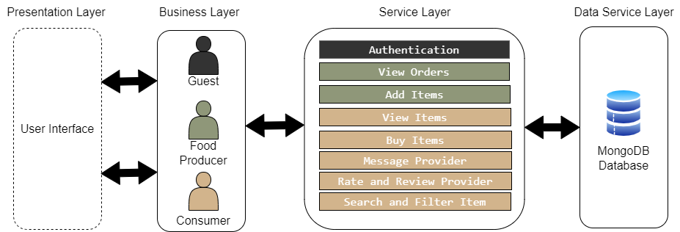
Fig. 5.1. Architecture Diagram

Presentation Layer : This is the topmost layer which is responsible for managing the user interface, facilitating the interaction between user and system.
Business Layer : This layer oversees the interaction between guest, food producer and consumer within the system.
Service Layer : This layer lists various services that the user can interact with. These services include authentication, order viewing, item addition, item viewing, item purchase, messaging, provider rating and reviewing, as well as item searching and filtering.
Data Service Layer : This is the bottom layer, represented by MongoDB. MongoDB is used to store data related to users, food items, chats and reviews.

6. DETAILED DESIGN
6.1 CLASS DIAGRAM
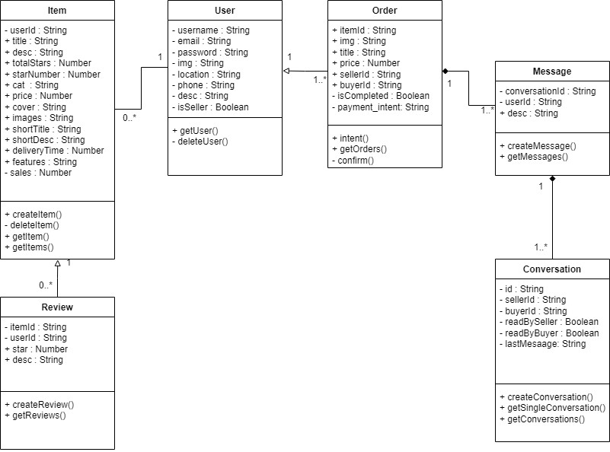

Fig. 6.1. Class Diagram
User : This class has attributes like username (string), email (string), password (string), img (string), location (string), phone (string), desc (string), isSeller (boolean). It has methods like getUser(), deleteUser().
Item : This class has attributes like userId (string), title (string), desc(string), totalStars (number) ,starNumber (number), cat (string), price(number), cover (string), images (string), shortTitle (string), shortDesc (string), deilveryTime (number), features (string), sales (number). It has methods like createItem(), deleteItem(), getItem(), getItems().
Order : This class has attributes like itemId (string), img (string), title (string), price (number), sellerId (string), buyerId (string), isCompleted (Boolean), payment_intent (string). It has methods like intent(), getOrders(), Confirm().
Message : This class has attributes like conversationId (string), userId (string), desc (string). It has methods like createMessage(), getMessages().
Conversation : This class has attributes like id (string), sellerId (string), buyerId (string), readBySeller : (Boolean), readByBuyer (Boolean), lastMessage (string). It has methods like createConversation(), getSingleConversation(), getConversations().
Review : This class has attributes like itemId (string), userId (string), star (number), desc (string). It has methods like createReview(), getReviews().

6.2 USE CASE DIAGRAM
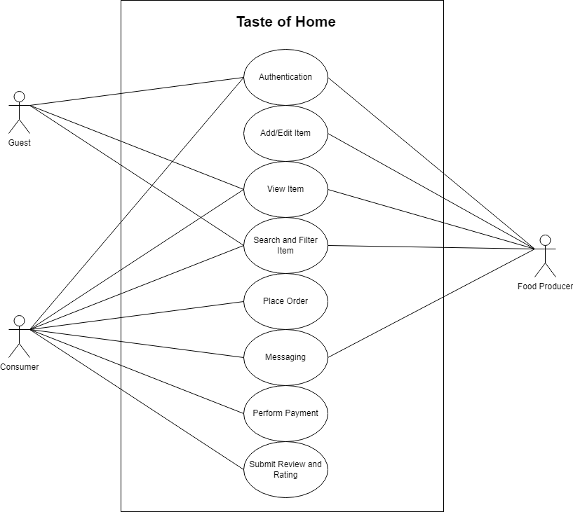
Fig. 6.2. Use Case Diagram
Actors: The guest, the consumer, and the food producer are the three actors in this diagram.
Authentication: Using the website, guests, consumers, and food producers may all authenticate.
Add/Edit Item : Food Producer can add or edit item in listing.
View Item : Guest, Consumer and Food Producer can view item.
Search and Filter Item : Guest, Consumer and Food Producer can search for specific item.
Place order : Consumer can place order.
Messaging : Consumer and Food Producer can message with each other.
Perform Payment : Consumer can make payments
Submit Review and Ratings : Consumer can provide feedback on food item.

6.3.1 ACTIVITY DIAGRAM - GUEST
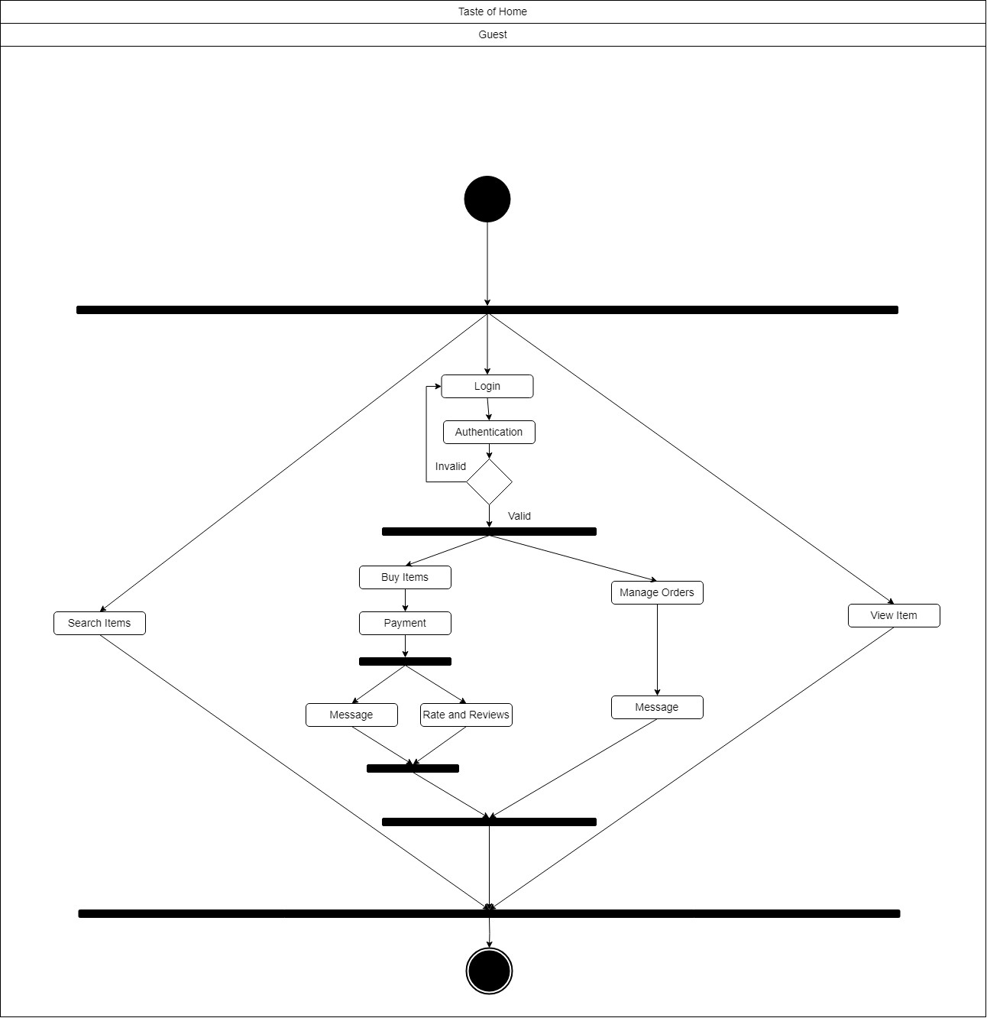

Fig 6.3.1 Activity Diagram - Guest
The activity diagram illustrates the user interaction flow within the application. Starting as a guest, the activity begins with the user having three primary options: searching for items, viewing items, or logging in. If the user opts for login, a valid authentication is necessary for further actions.
After logging in successfully, the user is given two options. The user may message food producers and handle orders through one channel. The other route enables the consumer to continue purchasing goods, complete payments, and then choose to write a message or leave a rating and review.
The several routes a user can take depending on their initial position as a visitor and subsequent selections made inside the application are captured by this organized activity flow.
6.3.2 ACTIVITY DIAGRAM – CONSUMER
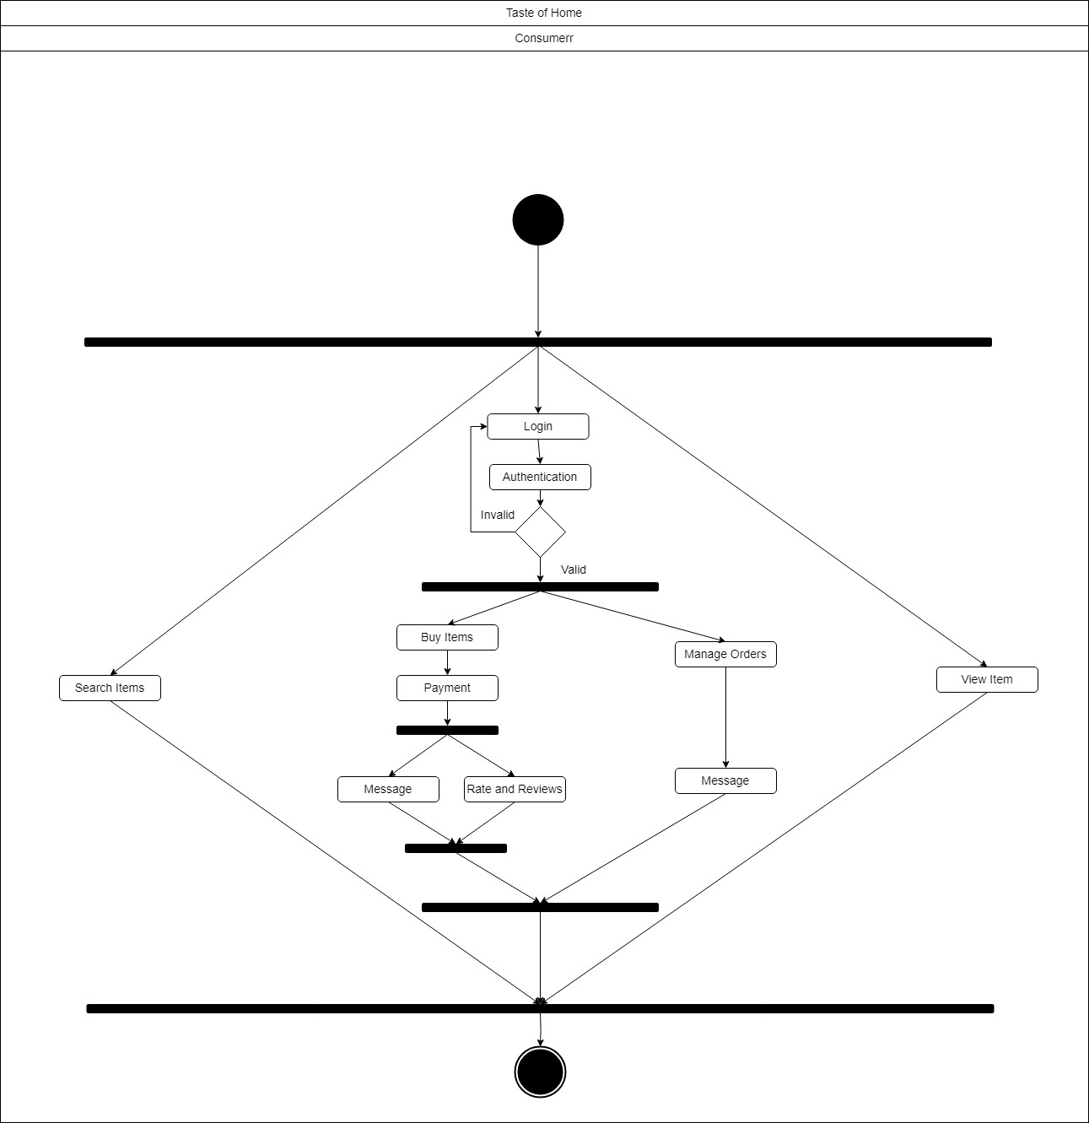
Fig 6.3.2 Activity Diagram – Consumer
The application's user interaction flow is depicted in the activity diagram. The user has three main alternatives when starting the activity as a consumer: looking for products, browsing items, or logging in. In the event that the user chooses to log in, additional activities need a successful authentication.
After logging in successfully, the user is given two options. The user may message food producers and handle orders through one channel. The other route enables the consumer to continue purchasing goods, complete payments, and then choose to write a message or leave a rating and review.
The several routes a user can take depending on their starting position as a customer and the decisions they make later in the application are captured by this organized activity flow.

6.3.3 ACTIVITY DIAGRAM – FOOD PRODUCER
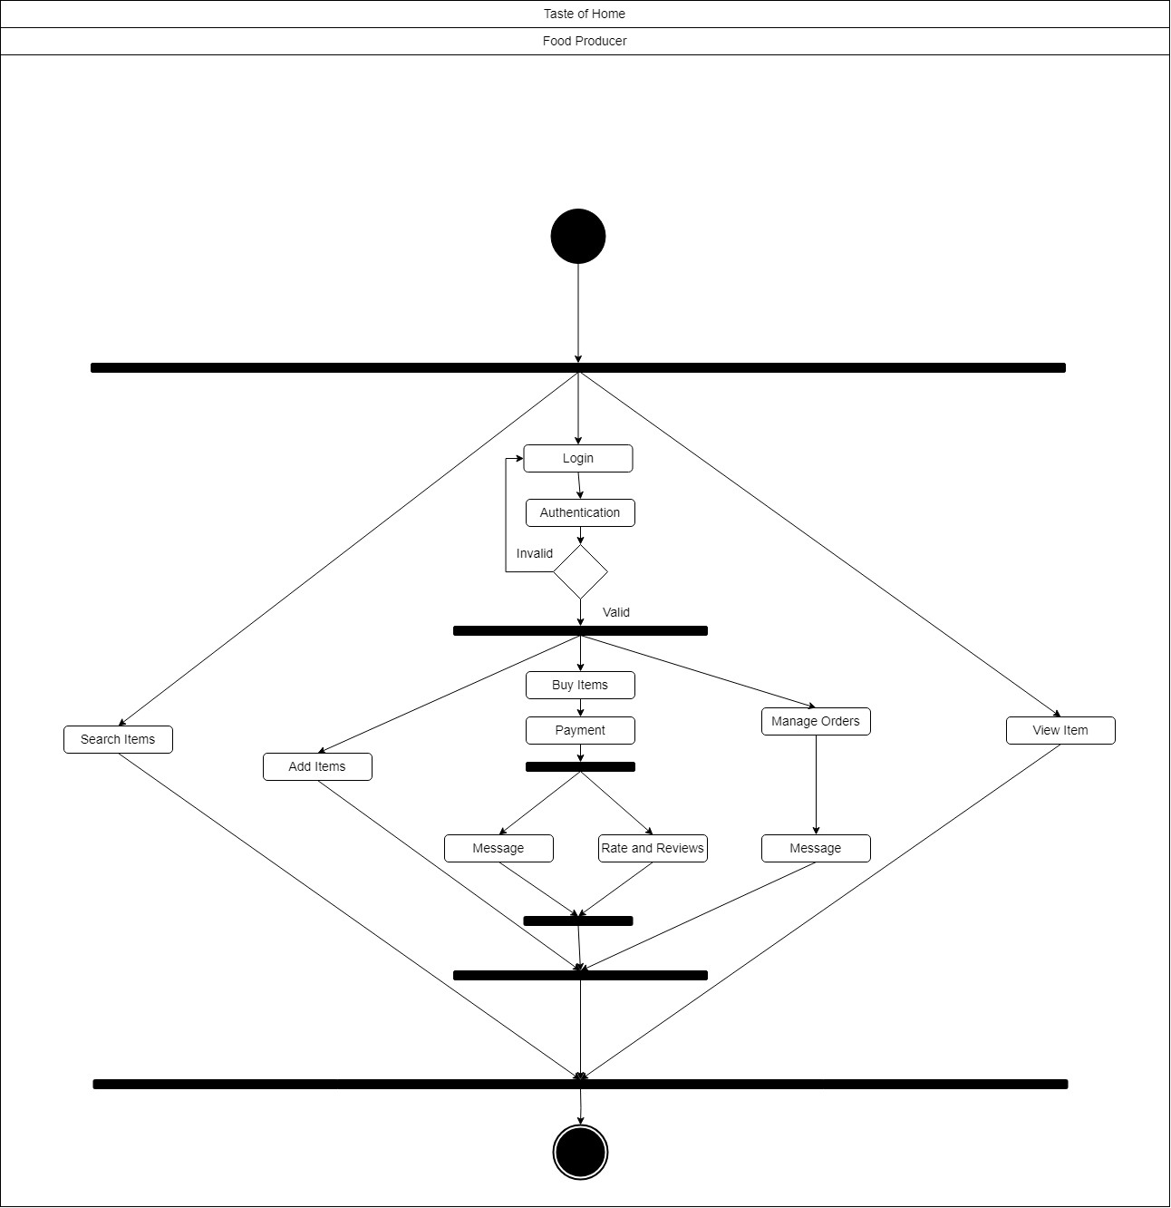
Fig 6.3.3 Activity Diagram – Food Producer

Three main options are available through the food producer interface:
- Search Item: Enables food producer to search for specific items within the platform.
- View Item: Allows food producer to preview details and information about a selected item.
- Login: Grants access to additional features. Once logged in, food producer are presented with three more options:
  - Add Item: Facilitates the addition of new items to the platform.
  - Manage Orders: Offers tools to oversee user's order history.
  - Buy Items: Initiates the purchasing process. Following a successful purchase, users come across two possibilities after purchasing:
    - Message: Enables users to interact with pertinent users.
    - Rate and Review: By giving ratings and writing reviews, users express their opinions and life experiences.

6.4 DATABASE DESIGN
6.4.1 DOCUMENT STRUCTURE (USER)
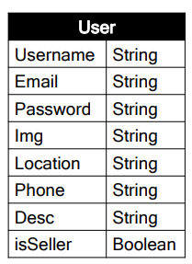
Fig 6.4.1 Document Structure (User)

6.4.2 DOCUMENT STRUCTURE (ITEM)
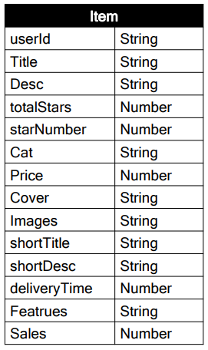
Fig 6.4.2 Document Structure (Item)

6.4.3 DOCUMENT STRUCTURE (ORDER)
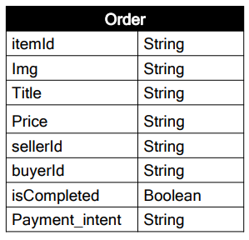
Fig 6.4.3 Document Structure (Order)

6.4.4 DOCUMENT STRUCTURE (REVIEW)
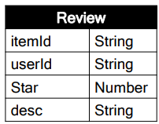
Fig 6.4.4 Document Structure (Review)

6.4.5 DOCUMENT STRUCTURE (CONVERSATION)
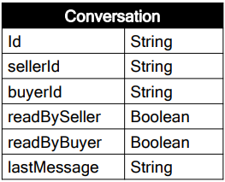
Fig 6.4.5 Document Structure (Conversation)

6.4.6 DOCUMENT STRUCTURE (MESSAGE)
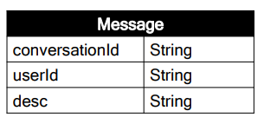
Fig 6.4.6 Document Structure (Message)

7. IMPLEMENTATION
7.1 SCREENSHOTS (HOME)
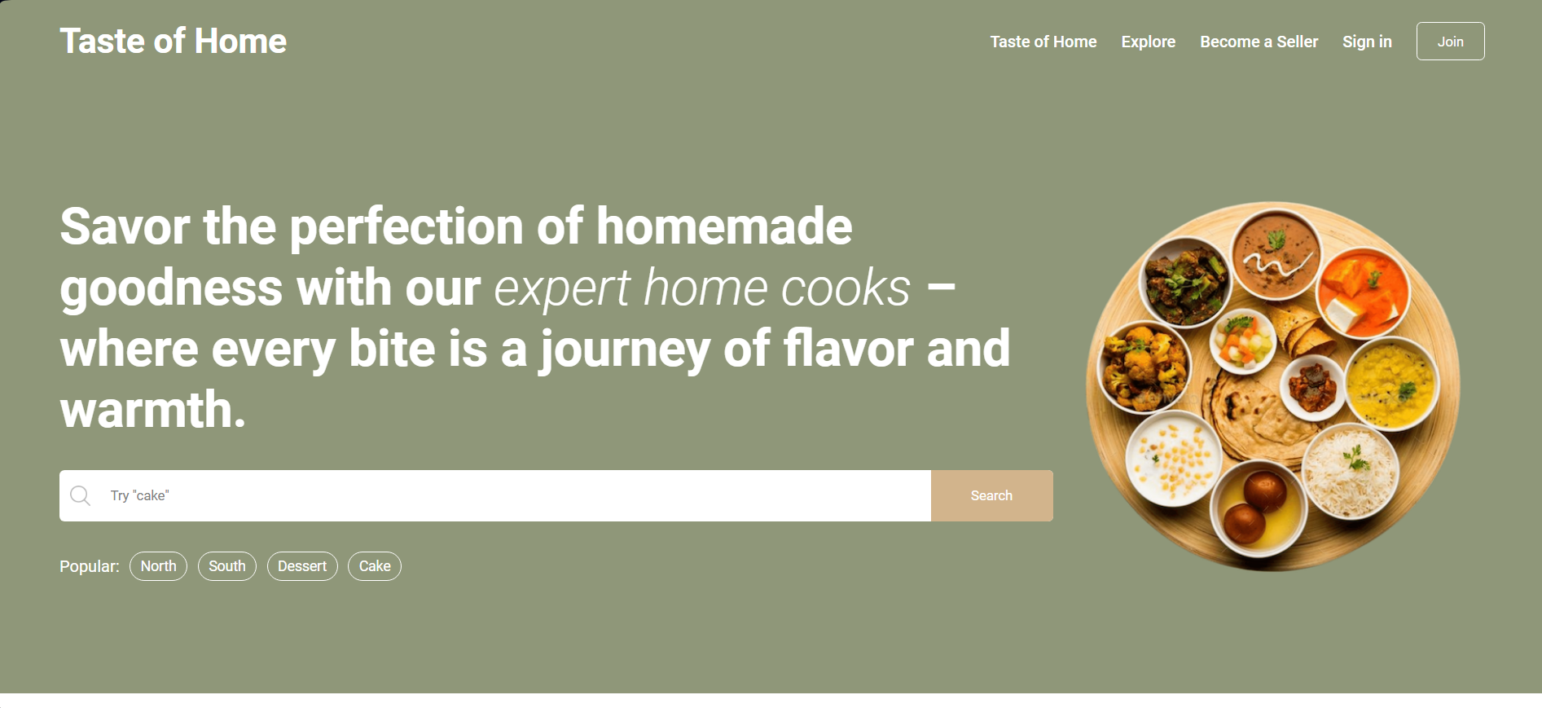
Fig 7.1 Home Page
7.2 SCREENSHOTS (EXPLORE)
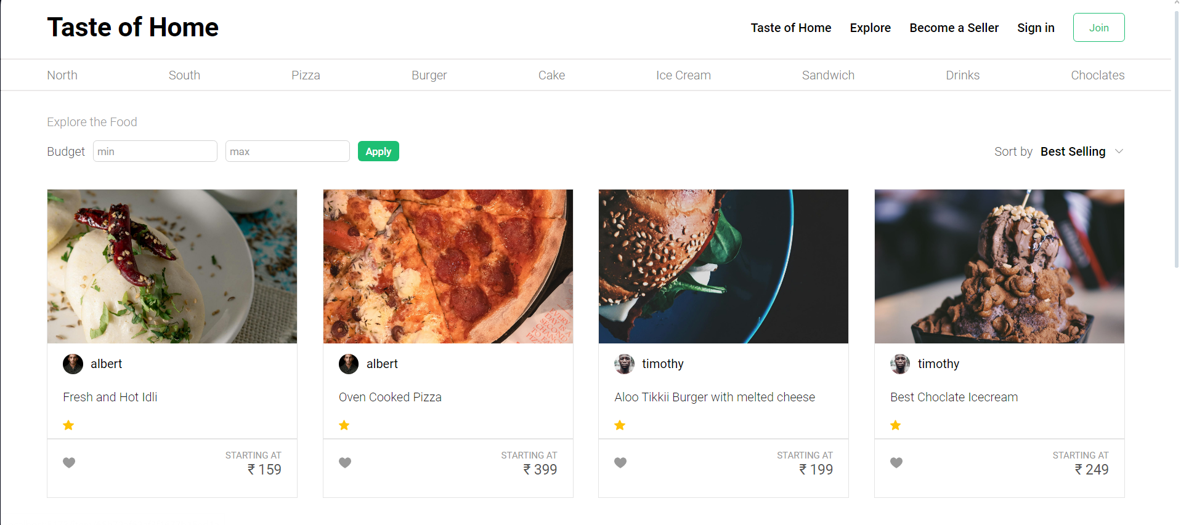
Fig 7.2 Explore Page
7.3 SCREENSHOTS (ITEM)
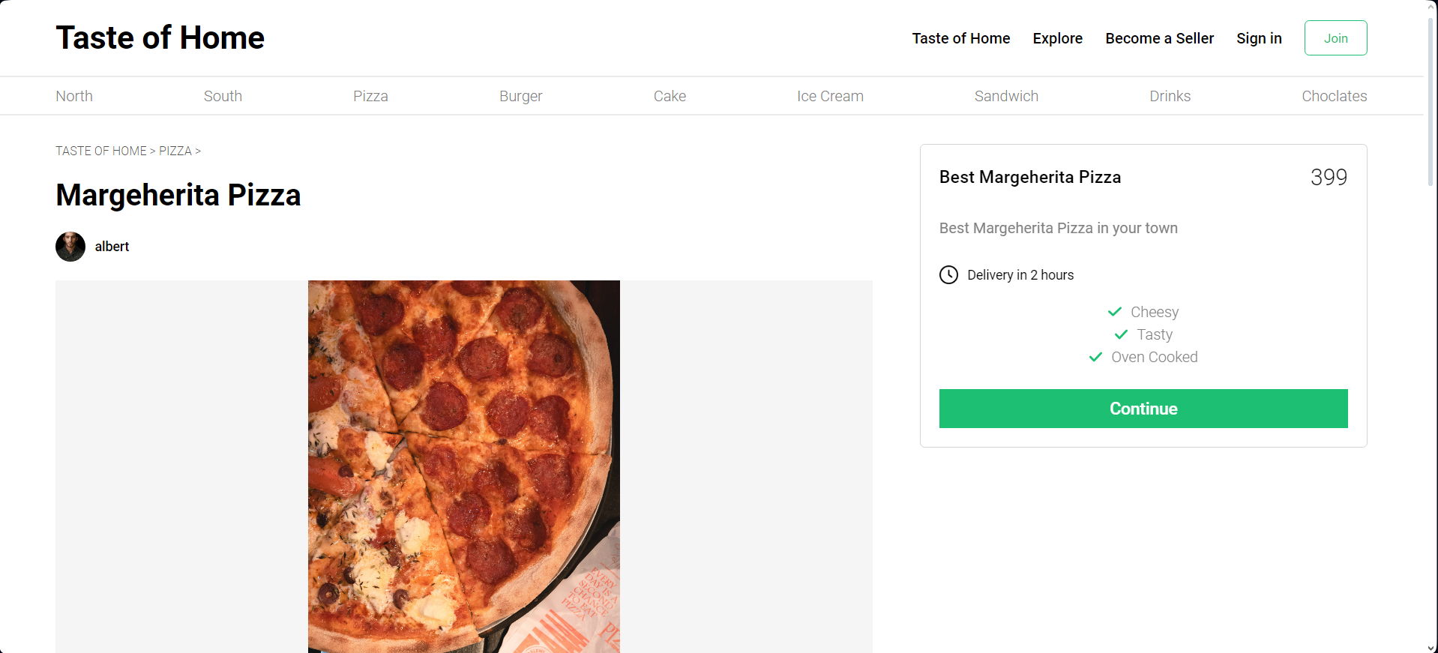
Fig 7.3 Item Page
7.4 SCREENSHOTS (REGISTER)
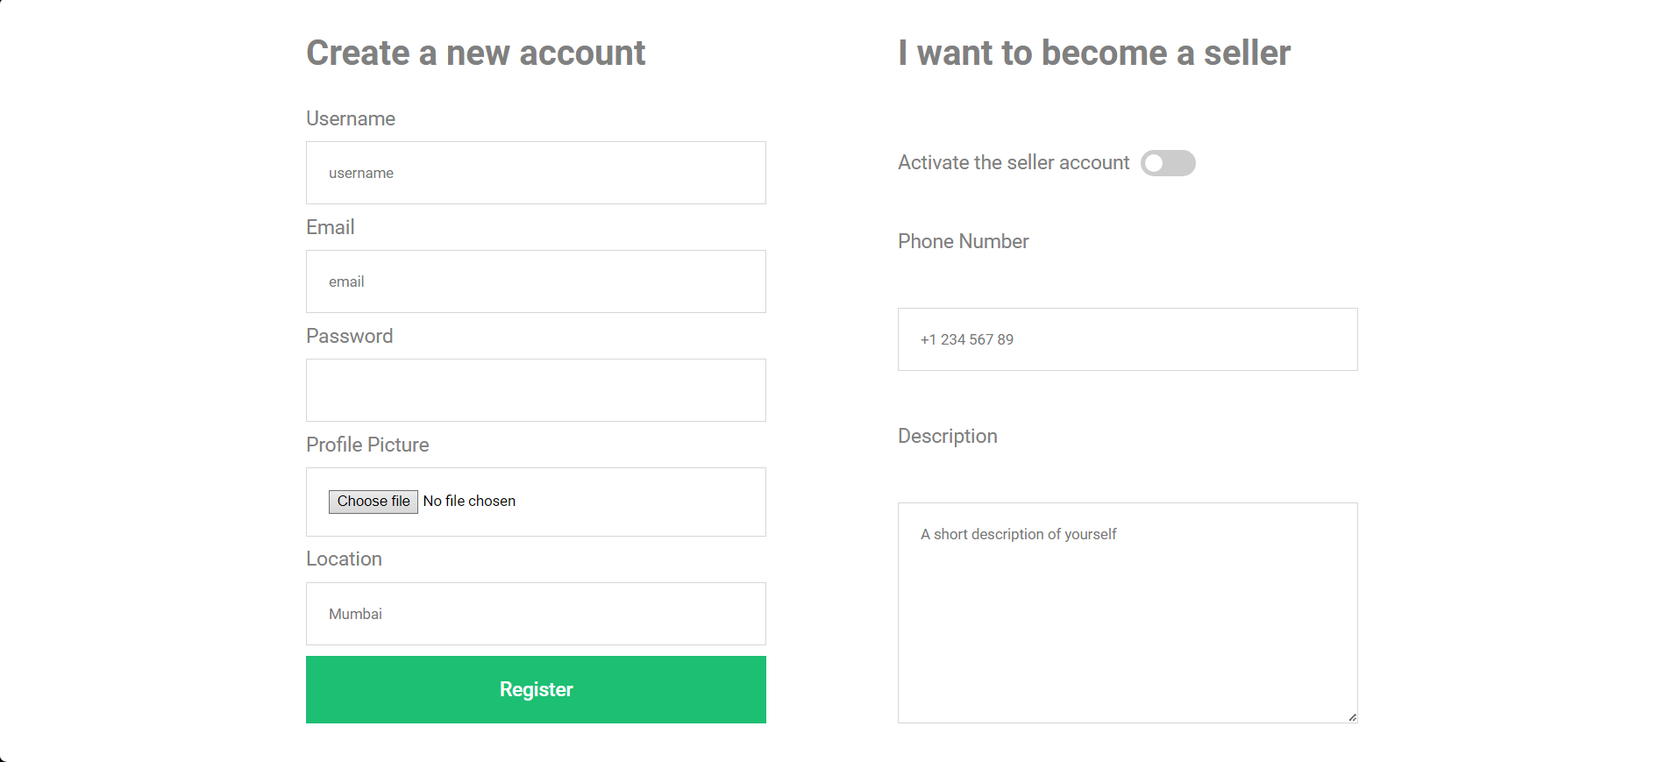
Fig 7.4 Register Page

7.5 SCREENSHOTS (LOGIN)
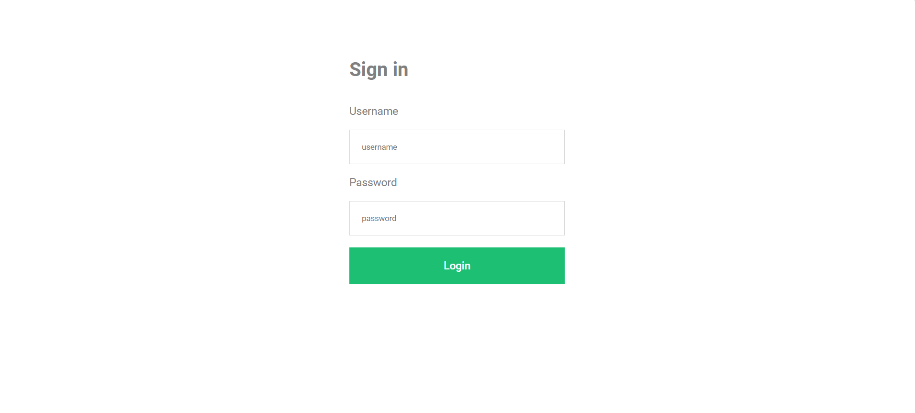
Fig 7.5 Login Page
7.6 SCREENSHOTS (ORDERS)
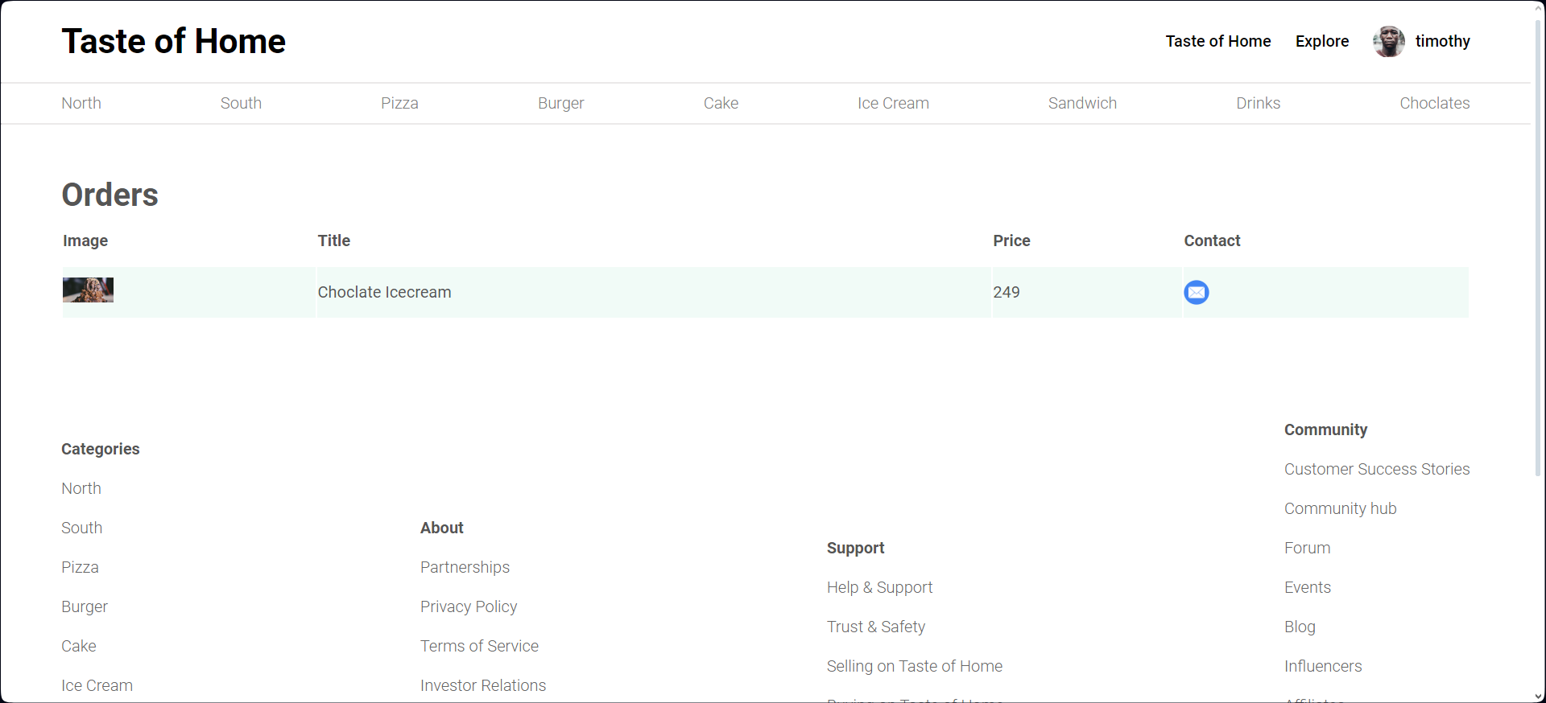
Fig 7.6 Orders Page

7.7 SCREENSHOTS (ADD NEW ITEM)
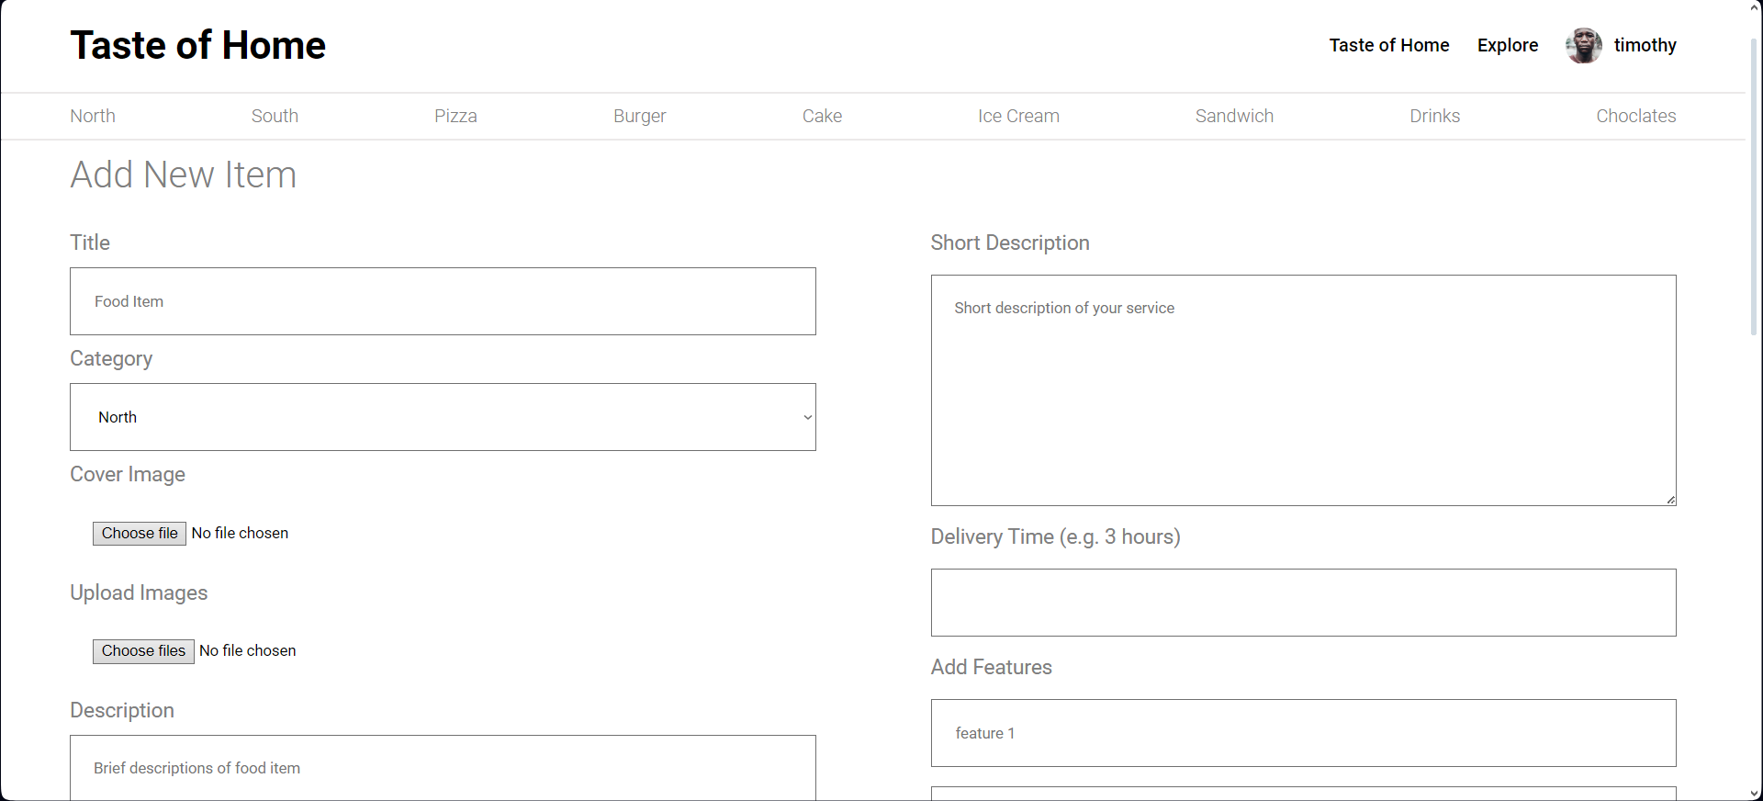
Fig 7.6 Add new item page

8. SOFTWARE TESTING
Test Scenario | Registration
Test Case ID | Step Details | Expected  Result | Actual Result | Pass/Fail/Non Executed/Suspended
TC01 | valid username and password | Successful account creation | Successful account creation | Pass
TC02 | Empty /Invalid Email | Error message | Error message | Fail
TC03 | Empty /Invalid Password | Error message | Error message | Fail
Table 8.1: Test Case : Registration Table

Test Scenario | Login
Test Case ID | Step Details | Expected Result | Actual Result | Pass/Fail/Non Executed/Suspended
TC04 | Valid Email id/Password | Successful log-in and redirection to the home page | Successful log-in and redirection to the home page | Pass
TCO5 | Invalid Email/Password | Error Message | Error Message | Fail
Table 8.2: Test Case : Log-in
Test Scenario | Payment
Test Case ID | Step Details | Expected Result | Actual Result | Pass/Fail/Non Executed/Suspended
TC06 | Valid name,email,card number,expiry date and cvv | payment processed,  order placed | payment processed,  order placed | Pass
TC07 | Leave one or more fields blank | Error message | Error message | Fail
TC08 | Invalid Card number | Error message | Error message | Fail
TC09 | Expired card expiry date | Error message | Error message | Fail
Table 8.3: Test Case : Payment
Test Scenario | Item Change
Test Scenario | Step Details | Expected Result | Actual Result | Pass/Fail
TC11 | Update Item Details | Details Updated successfully | Details Updated successfully | Pass
TC12 | Delete Item | Item deleted | Item deleted | Pass
TC13 | Add new Item | Item added successfully | Item added successfully | Pass
Table 8.3: Test Case : Item Change

9. CONCLUSION
To sum up, Taste of Home is a trailblazing approach to the food scene that successfully uses an inventive MERN stack online platform to connect enthusiastic local food producers with eager consumers. By championing a community-driven model, Taste of Home not only promotes local culinary talents but also addresses significant issues such as food waste and food security. The platform's robust features, including user profiles, detailed listings, integrated messaging, reviews and ratings, secure payment integration, and intuitive dashboards, collectively foster a thriving ecosystem that celebrates the authenticity of homemade food. As Taste of Home continues to grow, it aspires to make a substantial impact on local economies, strengthen community connections, and redefine the way people experience and share culinary delights.

APPENDIX A
BIBILOGRAPHY
[1] A REAL TIME WEB SERVICE SYSTEM FOR FOOD DELIVERY | Journal of Data Acquisition and Processing | 2023 | https://sjcjycl.cn/article/view-2023/pdf/02_1628.pdf

[2] Causal analysis of factors contributing to food wastage in restaurants of India | International Conference on Computational Intelligence and Sustainable Engineering Solutions (CISES) | 2023-12-27 | https://ieeexplore.ieee.org/document/10183615

[3] Food Ordering website "Cooked with care" developed using MERN stack | IEEE Xplore | 2022 | https://www.researchgate.net/publication/361178168_Food_Ordering_website_Cooked_with_care_developed_using_MERN_stack

[4] Web Based Application for Ordering Food Raw Materials | 1st International Conference on Computer Science and Artificial Intelligence | 2021 | https://ieeexplore.ieee.org/document/9609733

[5] Design of Web App for Online Food Services | International Journal for Research in Applied Science & Engineering Technology (IJRASET) | May 2022 | https://www.ijraset.com/research-paper/design-of-web-app-for-online-food-services

[6] E-Commerce web Application by using MERN Technology | International Journal for Modern Trends in Science and Technology | June 2021| https://www.ijmtst.com/vol7issue05.html

[7] MERN Stack Web Development | Annals of R.S.C.B | May 2021 | http://annalsofrscb.ro/index.php/journal

[8] CHALLENGES OF FOOD SECURITY | International Conference on Research in Humanities, Applied Sciences and Education| June 5th 2022| https://www.researchgate.net/publication/312093853_Challenges_of_Food_Security_in_India

[9] Investigating the Feasibility of a Restaurant Delivery Service to Improve Food Security among College Students Experiencing Marginal Food Security, a Head-to-Head Trial with Grocery Store Gift Cards | Int. J. Environ. Res. Public Health | 2021 | https://doi.org/10.3390/ijerph18189680

[10] Implementation of RESTful API Web Services Architecture in Takeaway Application Development | 1st International Conference on Electronic and Electrical Engineering and Intelligent System (ICE3IS)| 2021 | https://ieeexplore.ieee.org/document/9649679

[11] Solving Food Wastage issues through BYOD application | Fifth National Conference of Saudi Computers Colleges (NCCC) | 2022 | https://ieeexplore.ieee.org/document/10067735

[12] Review of Online Food Delivery Platforms and their Impacts on Sustainability | Fifth National Conference of Saudi Computers Colleges (NCCC) | 8 July 2020| https://ideas.repec.org/a/gam/jsusta/v12y2020i14p5528-d382021.html

APPENDIX B
PLAGIARIASM REPORT
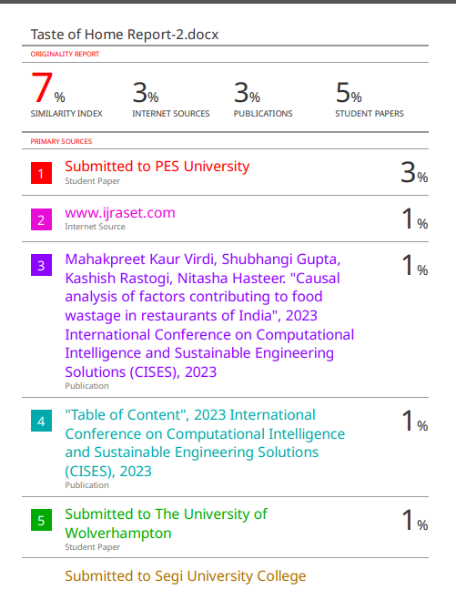
APPENDIX C
POSTER
